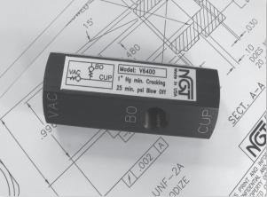

**VALVE APPLICATION & FUNCTION**

* Internal check maintains vacuum when the vacuum supply is removed
* Vacuum is applied to the vacuum port in order to pick up a part
* Pressure is applied to the Blow-Off port to eject the part from the vacuum cup
* Good for suction cups
* 3/8” NPT VAC & CUP ports and an 1/8” NPT Blow-Off port

|  |  |
| --- | --- |
| **TECHNICAL DATA** | |
| *Part Number:* | V6200 |
| *Button Type:* | None |
| *Port Sizes:* | 3/8” NPTF Both Ends |
| *Blow Off Port:* | 1/8” NPTF |
| *Min. Blow off:* | 25 psi |
| *Temp. Range:* | 30° – 150° F |
| *Flow Capacity:* | .6 |
| *Vacuum Cracking:* | 1 in Hg. |
| *Service:* | Filtered dry air or lubricated air |

