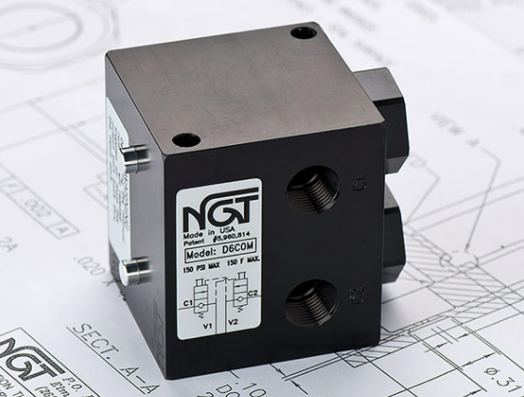

**VALVE APPLICATION & FUNCTION**

* Internal flow controls meter air out of the cylinder
* Dual valves perform the work of two PO check valves, but in one valve package, eliminating pilot lines
* Maintains cylinder position by locking air in cylinder
* Cross-ported to allow the valve to open when the control valve changes direction
* Work well in either vertical or horizontal applications ensuring precise stopping on machines with rollers or slides and eliminates some bounce
* Improves bounce vs. a single PO check since the valve checks in both directions

|  |  |  |  |
| --- | --- | --- | --- |
| **TECHNICAL DATA** | | | |
| *Part Number:* | D8C00 | D8C0M | D8CFM |
| *Button Type:* | None | Standard | Flush |
| *Port Sizes:* | 1/2” NPTF IN/OUT | | |
| *Pilot Port:* | None | | |
| *Max. Pressure:* | 150 psi | | |
| *Min. Pilot Pressure:* | 40 psi  20 psi option (see table `–K18’) | | |
| *Adv & Retract Ratio:* | The pressure ratio of advance/retract or retract/advance should not be greater than 2 | | |
| *Leak Rate:* | .0000522 cc/min | | |
| *Temp. Range:* | -20° - 150° F  30° - 350° F | | |
| *Cycle Rate:* | 1 cyc./sec. max. | | |
| *Flow Capacity:* | 3.8 (Cv) | | |
| *Cracking Press:* | 1-2 psi | | |
| *Service:* | Filtered dry air or lubricated air | | |

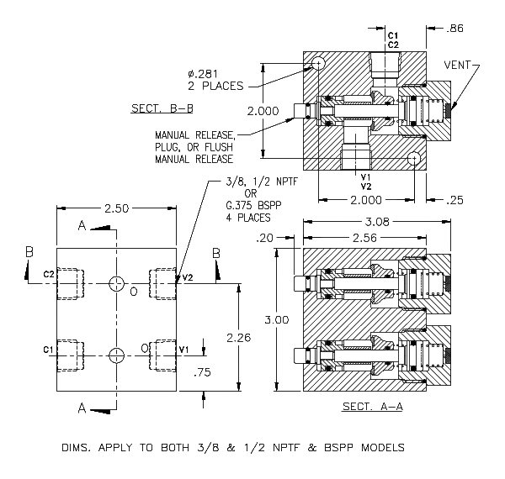

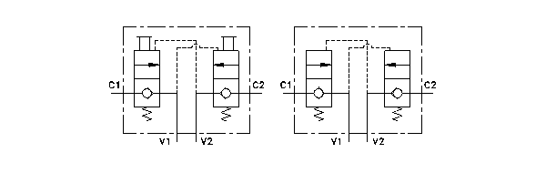

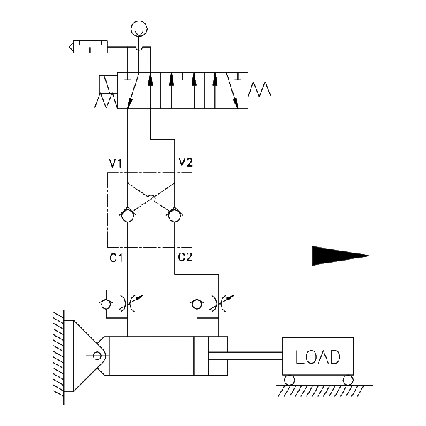

For high temp seals *(30*°*-350*° *F)* add (-V) to the model

For low temp seals *(-40*°*-150*° *F)* add (-T40) to the model

For a lower pilot pressure add (-K18) (ex. D8CXX-K18)