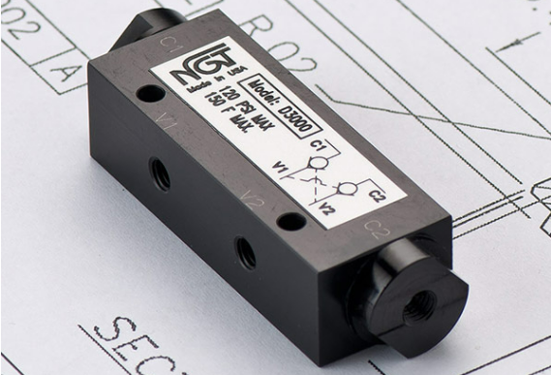

**VALVE APPLICATION & FUNCTION**

* Internal flow controls meter air out of the cylinder
* Dual valves perform the work of two PO check valves, but in one valve package, eliminating pilot lines
* Maintains cylinder position by locking air in cylinder
* Cross-ported to allow the valve to open when the control valve changes direction
* Work well in either vertical or horizontal applications ensuring precise stopping on machines with rollers or slides and eliminates some bounce
* Improves bounce vs. a single PO check since the valve checks in both directions

|  |  |
| --- | --- |
| **TECHNICAL DATA** | |
| *Part Number:* | D3000 |
| *Port Sizes:* | 10/32 |
| *Pilot Port:* | None |
| *Max. Pressure:* | 25 - 120 psi |
| *Min. Pilot Pressure:* | N/A |
| *Temp. Range:* | 30° - 150° F |
| *Cycle Rate:* | 1 cyc./sec. max. |
| *Flow Capacity:* | .25 (Cv) |
| *Cracking Press:* | 1-2 psi |
| *Service:* | Filtered dry air or lubricated air |

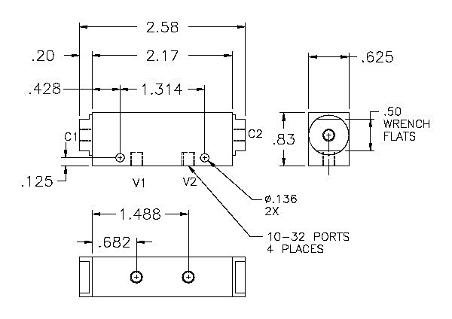

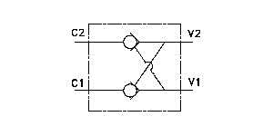

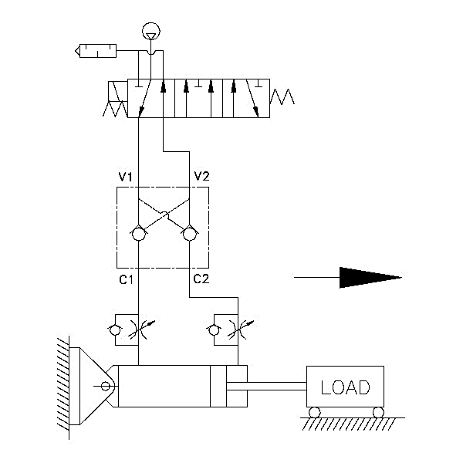

For high temp seals *(30*°*-350*° *F)* add (-V) to the model

For low temp seals *(-40*°*-150*° *F)* add (-T40) to the model

For a lower pilot pressure add (-K18) (ex. D3000-K18)