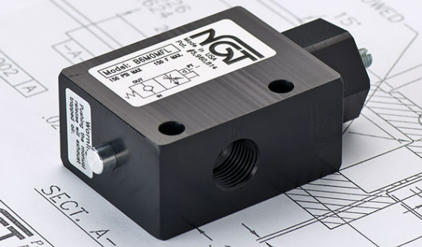

**VALVE APPLICATION & FUNCTION**

* Helps prevent crash landings & cylinder bounce
* Slow down how quickly the valve exhausts
* Less expensive than a separate needle valve, but doesn’t allow for fine adjustment
* Compact package, simple piping
* Ideal for large cylinders, where a slight restriction on exhaust speed is all you need

|  |  |  |  |
| --- | --- | --- | --- |
| **TECHNICAL DATA** | | | |
| *Part Number:* | BG6M00FL | BG6M0MFL | BG6MFMFL |
| *Button Type:* | None | Standard | Flush |
| *Port Sizes:* | 3/8” BSPP IN/OUT | | |
| *Pilot Port:* | 1/4" BSPP | | |
| *Max. Pressure:* | 150 psi | | |
| *Min. Pilot Pressure:* | 40 psi  25 psi (see table) | | |
| *Leak Rate:* | .0000522 cc/min | | |
| *Temp. Range:* | 30° – 150° F | | |
| *Cycle Rate:* | 1 cyc./sec. max. | | |
| *Flow Capacity:* | 2.6 (Cv) | | |
| *Cracking Press:* | 1-2 psi | | |
| *Service:* | Filtered dry air or lubricated air | | |

*For high temp seals (30*°*-350*° *F) add (-V) to the model*

*For low temp seals (-40*°*-150*° *F) add (-T40) to the model*

*For a lower pilot pressure add (-K18) to the model*

*(ex. BG6MXXFL-T40)*

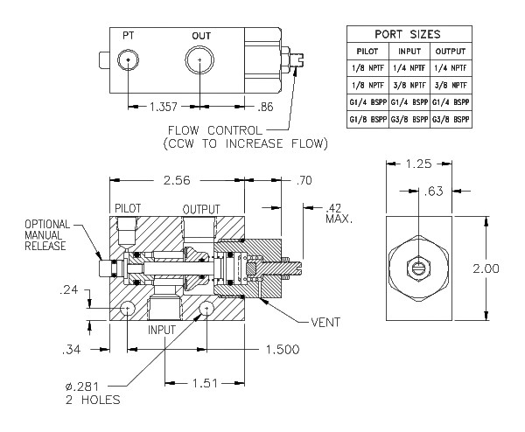

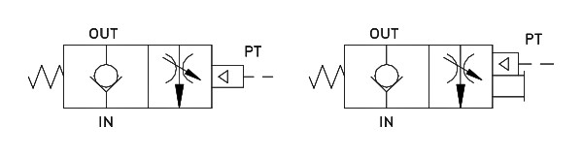

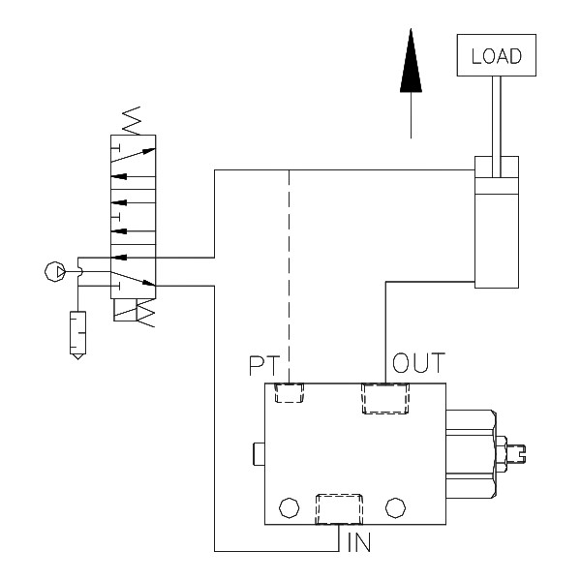

|  |  |  |  |  |  |  |
| --- | --- | --- | --- | --- | --- | --- |
| ***Turns*** | *.25* | *.50* | *.75* | *1.0* | *1.25* | *1.5* |
| ***Equivalent Dia. (in)*** | *.15* | *.21* | *.26* | *.30* | *.34* | *.37* |
| ***Turns*** | *1.75* | *2.00* | *2.25* | *2.50* | *2.75* |  |
| ***Equivalent Dia. (in)*** | *.40* | *.43* | *.45* | *.48* | *.50* |  |