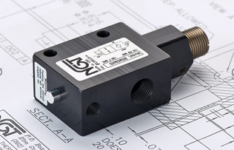

**VALVE APPLICATION AND FUNCTION**

* Adjustable PO checks allow for quicker stops if a standard PO check valve is closing too slow or drifting after changing direction on the control valve
* Valve is adjustable to accommodate different pilot (signal)pressures
* Helpful if a standard PO check doesn’t close fast enough due to signal strength or length of pilot line
* Adjustable PO checks allow for quicker stops if a standard PO check valve is closing too slow or drifting after changing direction on the control valve
* This valve enables faster stops with lower pilot pressure

|  |  |  |  |
| --- | --- | --- | --- |
| **TECHNICAL DATA** | | | |
| *Part Number:* | BG4M00AD | BG4M0MAD | BG4MFMAD |
| *Button Type:* | None | Standard | Flush |
| *Port Sizes:* | 1/4” BSPP IN/OUT | | |
| *Pilot Port:* | 1/4" BSPP | | |
| *Max. Pressure:* | 120 psi | | |
| *Min. Pilot Pressure:* | Adjustable | | |
| *Leak Rate:* | .0000522 cc/min | | |
| *Temp. Range:* | 30° – 150° F | | |
| *Cycle Rate:* | 1 cyc./sec. max. | | |
| *Flow Capacity:* | 2.6 (Cv) | | |
| *Cracking Press:* | 1-2 psi | | |
| *Service:* | Filtered dry air or lubricated air | | |

*For high temp seals (30*°*-350*° *F) add (-V) to the model*

*For low temp seals (-40*°*-150*° *F) add (-T40) to the model*

