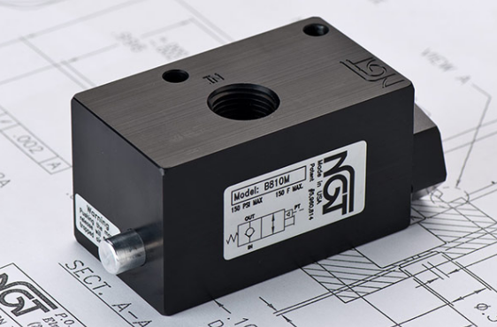

**VALVE APPLICATION & FUNCTION**

* NGT’s PO checks can be used in any pneumatic application where a sudden drop in pressure would harm personnel, damage products, or otherwise hinder the manufacturing process
* Typical applications of PO checks are clamping, work holding, & lifting equipment, doors, platforms, and material
* Air tight design means little to no leaking. Design tightens with increased pressure
* All aluminum o-ring grooves and faces are hard coat anodized with Teflon coating to reduce wear and increase seal life
* Nickel plated steel piston rod for strength and corrosion resistance

|  |  |  |  |
| --- | --- | --- | --- |
| **TECHNICAL DATA** | | | |
| *Part Number:* | B8100 | B810M | B81FM |
| *Button Type:* | None | Standard | Flush |
| *Port Sizes:* | 1/2” NPTF IN/OUT | | |
| *Pilot Port:* | 1/4" NPTF | | |
| *Max. Pressure:* | 150 psi | | |
| *Min. Pilot Pressure:* | 40 psi  25 psi (see table) | | |
| *Leak Rate:* | .0000522 cc/min | | |
| *Temp. Range:* | 30° – 150° F  30° – 350° F (see table ‘-V’)  -40° – 150° F (see table ‘-T40’) | | |
| *Cycle Rate:* | 1 cyc./sec. max. | | |
| *Flow Capacity:* | 3.8 (Cv) | | |
| *Cracking Press:* | 1-2 psi | | |
| *Service:* | Filtered dry air or lubricated air | | |

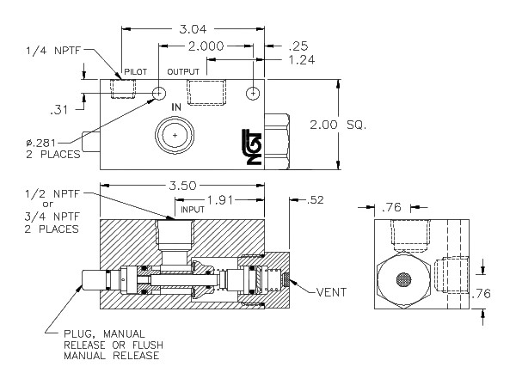

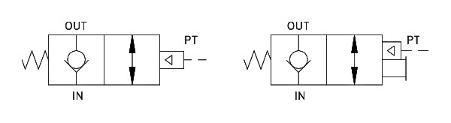

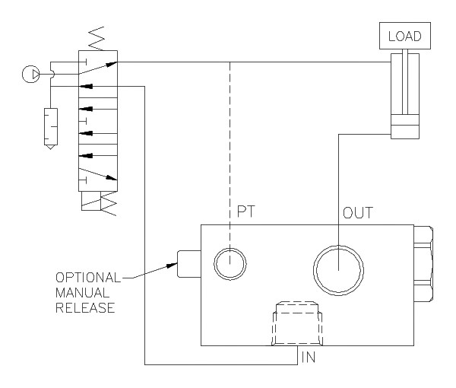

*For high temp seals (30*°-350° F*) add (-V) to the model*

*For low temp seals (-40*°-150° F*) add (-T40) to the model*

*For a lower pilot pressure add (-K18) to the model*

(ex. B81XX-T40)