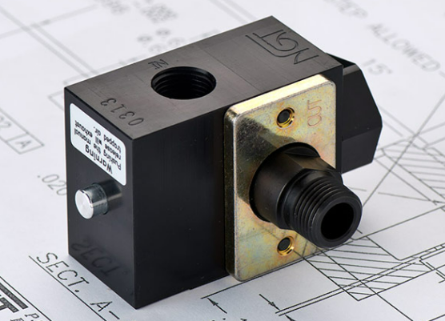

|  |  |  |  |
| --- | --- | --- | --- |
| **TECHNICAL DATA** | | | |
| *Button Type:* | None | Standard | Flush |
| *1/4” Outlet:* | B6S00-25 | B6S0M-25 | B6SFM-25 |
| *3/8” Outlet:* | B6S00-38 | B6S0M-38 | B6SFM-38 |
| *1/2” Outlet:* | B6S00-50 | B6S0M-50 | B6SFM-50 |
| *Input Port Size:* | 3/8” NPTF | | |
| *Pilot Port:* | *1/8” NPTF* | | |
| *Max. Pressure:* | 150 psi | | |
| *Min. Pilot Pressure:* | 40 psi  25 psi (see table) | | |
| *Leak Rate:* | .0000522 | | |
| *Temp. Range:* | 30° – 150° F  - 40° – 150° F (low temp) | | |
| *Cycle Rate:* | 1 cyc/sec. max. | | |
| *Flow Capacity:* | 2.6 | | |
| *Cracking Press:* | 1-2 psi | | |
| *Service:* | Filtered dry air or lubricated air | | |

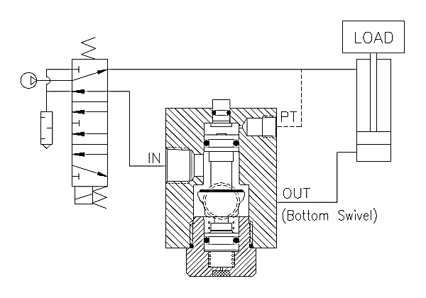

**VALVE APPLICATION & FUNCTION**

* Male outlet ports on swivel valves enable direct mounting to cylinders
* NGT’s PO checks can be used in any pneumatic application where a sudden drop in pressure would harm personnel, damage products, or otherwise hinder the manufacturing process
* Typical applications of PO checks are clamping, work holding, & lifting equipment, doors, platforms, and material
* Air tight design means little to no leaking. Design tightens with increased pressure
* All aluminum o-ring grooves and faces are hard coat anodized with Teflon coating to reduce wear and increase seal life
* Nickel plated steel piston rod for strength and corrosion resistance

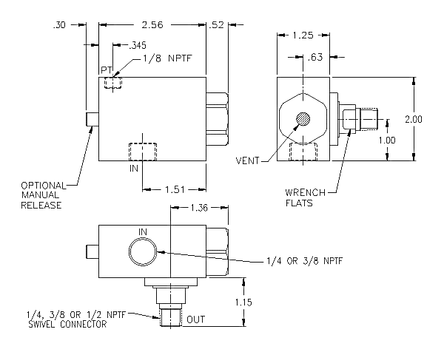

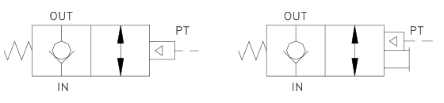

*For high temp seals (30*°*-350*° *F) add (-V) to the model*

*For low temp seals (-40*°*-150*° *F) add (-T40) to the model*

*For a lower pilot pressure add (-K18) to the model*

*(ex. B6SXX-XX-T40)*