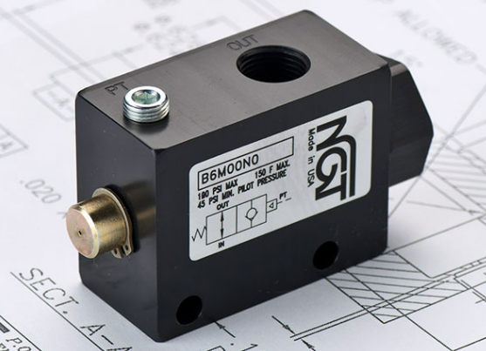

**VALVE APPLICATION & FUNCTION**

* Normally open valve that closes when pressure is applied to the pilot port.
* Valve opens when pilot pressure is released.
* Internal check allows free flow from input to output.

|  |  |
| --- | --- |
| **TECHNICAL DATA** | |
| *Part Number:* | B6M00N0 |
| *Button Type:* | Standard |
| *Port Sizes:* | 3/8” NPTF (In/Out) |
| *Pilot Port:* | N/A |
| *Pilot to Close:* | 45 psi min |
| *Max. Pressure:* | 120 psi |
| *Leak Rate:* | .000052 cc/min. |
| *Temp. Range:* | -20° – 150° F |
| *Cycle Rate:* | 1 cyc./sec. max. |
| *Flow Capacity:* | 2.6 (Cv) |
| *Cracking Press:* | 1- 2 psi |
| *Service:* | Filtered dry air or lubricated air |

Available in swivel configuration

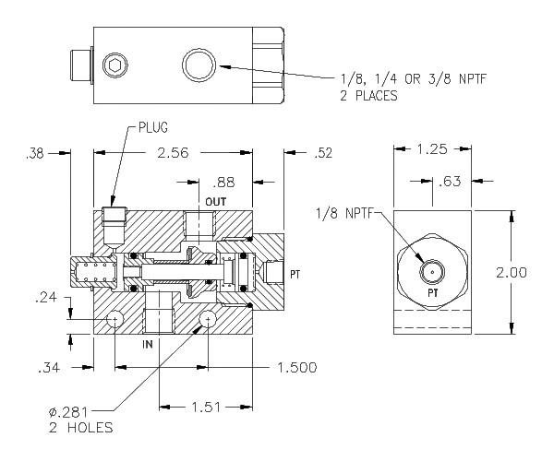

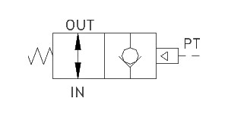

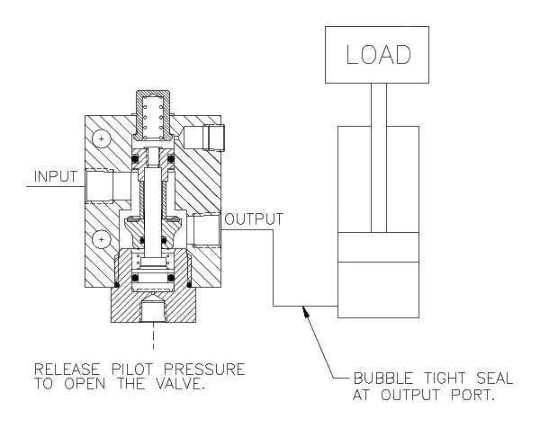

*For high temp seals (30*°*-350*° *F) add (-V) to the model*

*For low temp seals (-40*°*-150*° *F) add (-T40) to the model*

*(ex. B6M00N0-T40)*