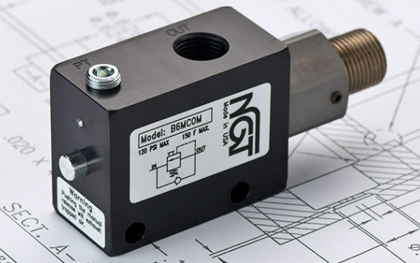

**VALVE APPLICATION & FUNCTION**

* Counterbalance valves are internally piloted: the pilot port is plugged, and the valve has a small channel connecting both sides
* When air is supplied to the other side of the cylinder (retract side), advance side will vent only after pilot signal is energized from pressure buildup on the advance
* Prevents runaway for vertical cylinders with load
* Can hold load in the middle of cylinder stroke
* Allow cylinder to travel at higher speeds
* Tightening the adjusting screw will increase spring tension holding the valve closed, making the valve more responsive

|  |  |  |  |
| --- | --- | --- | --- |
| **TECHNICAL DATA** | | | |
| *Part Number:* | B4MC00 | B4MC0M | B4MCFM |
| *Button Type:* | None | Standard | Flush |
| *Port Sizes:* | 1/4” NPTF IN/OUT | | |
| *Pilot Port:* | 1/4" NPTF | | |
| *Max. Pressure:* | 120 psi | | |
| *Leak Rate:* | .0000522 cc/min | | |
| *Temp. Range:* | 30° – 150° F | | |
| *Cycle Rate:* | 1 cyc./sec. max. | | |
| *Flow Capacity:* | 2.6 (Cv) | | |
| *Cracking Press:* | 1-2 psi | | |
| *Service:* | Filtered dry air or lubricated air | | |

*For high temp seals (30*°*-350*° *F) add (-V) to the model*

*For low temp seals (-40*°*-150*° *F) add (-T40) to the model*

*For a lower pilot pressure add (-K18) to the model*

*(ex. B4MCXX-T40)*

