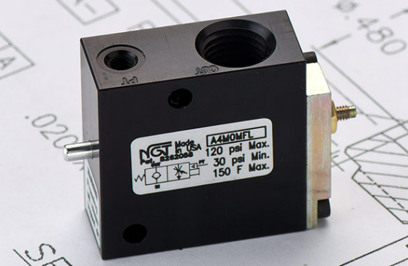

**VALVE APPLICATION & FUNCTION**

* Helps prevent crash landings & cylinder bounce
* Slow down how quickly the valve exhausts
* Less expensive than a separate needle valve, but doesn’t allow for fine adjustment
* Compact package, simple piping
* Ideal for large cylinders, where a slight restriction on exhaust speed is all you need

|  |  |
| --- | --- |
| **TECHNICAL DATA** | |
| *Part Number:* | A6M0MFL |
| *Button Type:* | Standard |
| *Port Sizes:* | 3/8” NPTF IN/OUT |
| *Pilot Port:* | 10 - 32 |
| *Max. Pressure:* | 120 psi |
| *Leak Rate:* | .000113 cc/min |
| *Temp. Range:* | 30° – 150° F |
| *Cycle Rate:* | 1 cyc./sec. max. |
| *Flow Capacity:* | 1.2 (Cv) |
| *Cracking Press:* | 2-3 psi |
| *Service:* | Filtered dry air or lubricated air |

