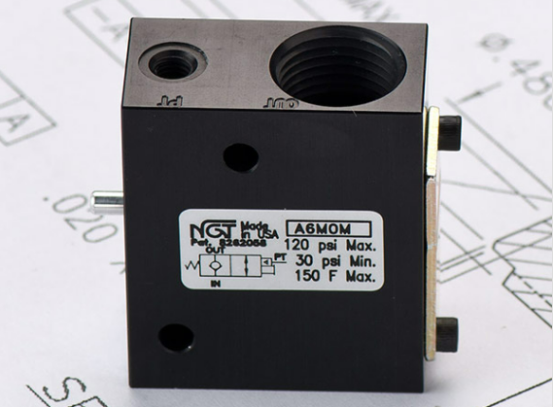

**VALVE APPLICATION & FUNCTION**

* NGT’s PO checks can be used in any pneumatic application where a sudden drop in pressure would harm personnel, damage products, or otherwise hinder the manufacturing process
* Typical applications of PO checks are clamping, work holding, & lifting equipment, doors, platforms, and material
* Air tight design means little to no leaking. Design tightens with increased pressure
* All aluminum o-ring grooves and faces are hard coat anodized with Teflon coating to reduce wear and increase seal life
* Nickel plated steel piston rod for strength and corrosion resistance

|  |  |
| --- | --- |
| **TECHNICAL DATA** | |
| *Part Number:* | A6M0M |
| *Button Type:* | Standard |
| *Port Sizes:* | 3/8” NPTF (In/Out) |
| *Pilot Port:* | 10 - 32 |
| *Min. Pilot Pressure:* | 30 psi @ 80 psi |
| *Max. Pressure:* | 120 psi |
| *Leak Rate:* | .000113 cc/min. |
| *Temp. Range:* | 30° – 150° F |
| *Cycle Rate:* | 1 cyc./sec. max. |
| *Flow Capacity:* | 1.2 (Cv) |
| *Cracking Press:* | 2 – 3 psi |
| *Service:* | Filtered dry air or lubricated air |

